Internship Application Tracker (IAT)
Aaron Kraska
University of Minnesota Crookston
SE 2300: Software Construction
Module 1 Assignment
January 19, 2026

Project Selection
The Internship Application Tracker (IAT) will be a single-user application that will help students organize and manage their internship and/or job applications. The user will be able to enter basic information, such as company name, role title, application link, application date, application status, and notes, and then be able to view them in a searchable, filterable list. This application will solve the issue of losing track of where/when you applied.
Additionally, this application will calculate a recommended follow-up date for each application. Instead of emails or notifications, the system will display a Follow-ups Due list in the application so that users can easily see which of their applications will need follow-ups.

Requirements Gathering
The Internship Application Tracker is designed as a single-user system and will not include any login or account functionality in Version 1 (V1). All application data will be stored locally so the system can be used offline, with SQLite serving as the storage solution. In addition, follow-up reminders will be handled entirely within the application, meaning the system will display follow-up information in-app rather than integrating with external services such as email or text messaging.
The system requirements for this project include both functional requirements, which describe what the system must do, and non-functional requirements, which describe quality attributes such as performance, usability, and reliability. These requirements define the expected behavior of the Internship Application Tracker and serve as the foundation for design decisions, testing, and validation.
# | FR | NFR
1 | The system shall allow the user to create a new internship application entry | The interface shall be simple enough for a user to add an application entry in < 1 minute
2 | The system shall display all saved application entries in a list view | The system shall load and display up to 500 applications in < 2 seconds on a standard computer
3 | The system shall allow the user to edit existing applications | The system shall not lose saved data during normal use
4 | The system shall allow a user to delete or archive existing application entries | The codebase shall follow consistent naming conventions and organization
5 | The system shall support a pre-defined set of application statuses | The system shall be compatible with Windows systems running Python
6 | The system shall automatically calculate a recommended follow-up date for each application entry | The system shall store data locally only and shall not transmit user data over a network
7 | The system shall display a list of applications with follow-up dates that are due on or before the current date | The interface shall use readable font sizes, have clear contrast, and support keyboard navigation for form entry
8 | The system shall allow for searching for applications by company name | N/A
9 | The system shall support filtering of applications by status | N/A
10 | The system shall display a count of all applications by status (e.g., Applied: 5, Interviewing: 2) | N/A
11 | The system shall store data locally and reload it when the program is reopened | N/A
12 | The system shall store application details, including Company, Role Title, Application Date, Status, Application Link (optional), and Notes (optional). | N/A
Table 1
Requirements Table
This project will be implemented using Python, which aligns with the programming language taught in this course and supports rapid development. The system will use local storage only, specifically SQLite, to ensure data is saved reliably without requiring internet access or external infrastructure. Finally, the system will not include external integrations such as email or text messaging in V1, which keeps the scope realistic and ensures the project can be completed within the given timeframe.

Architecture Design
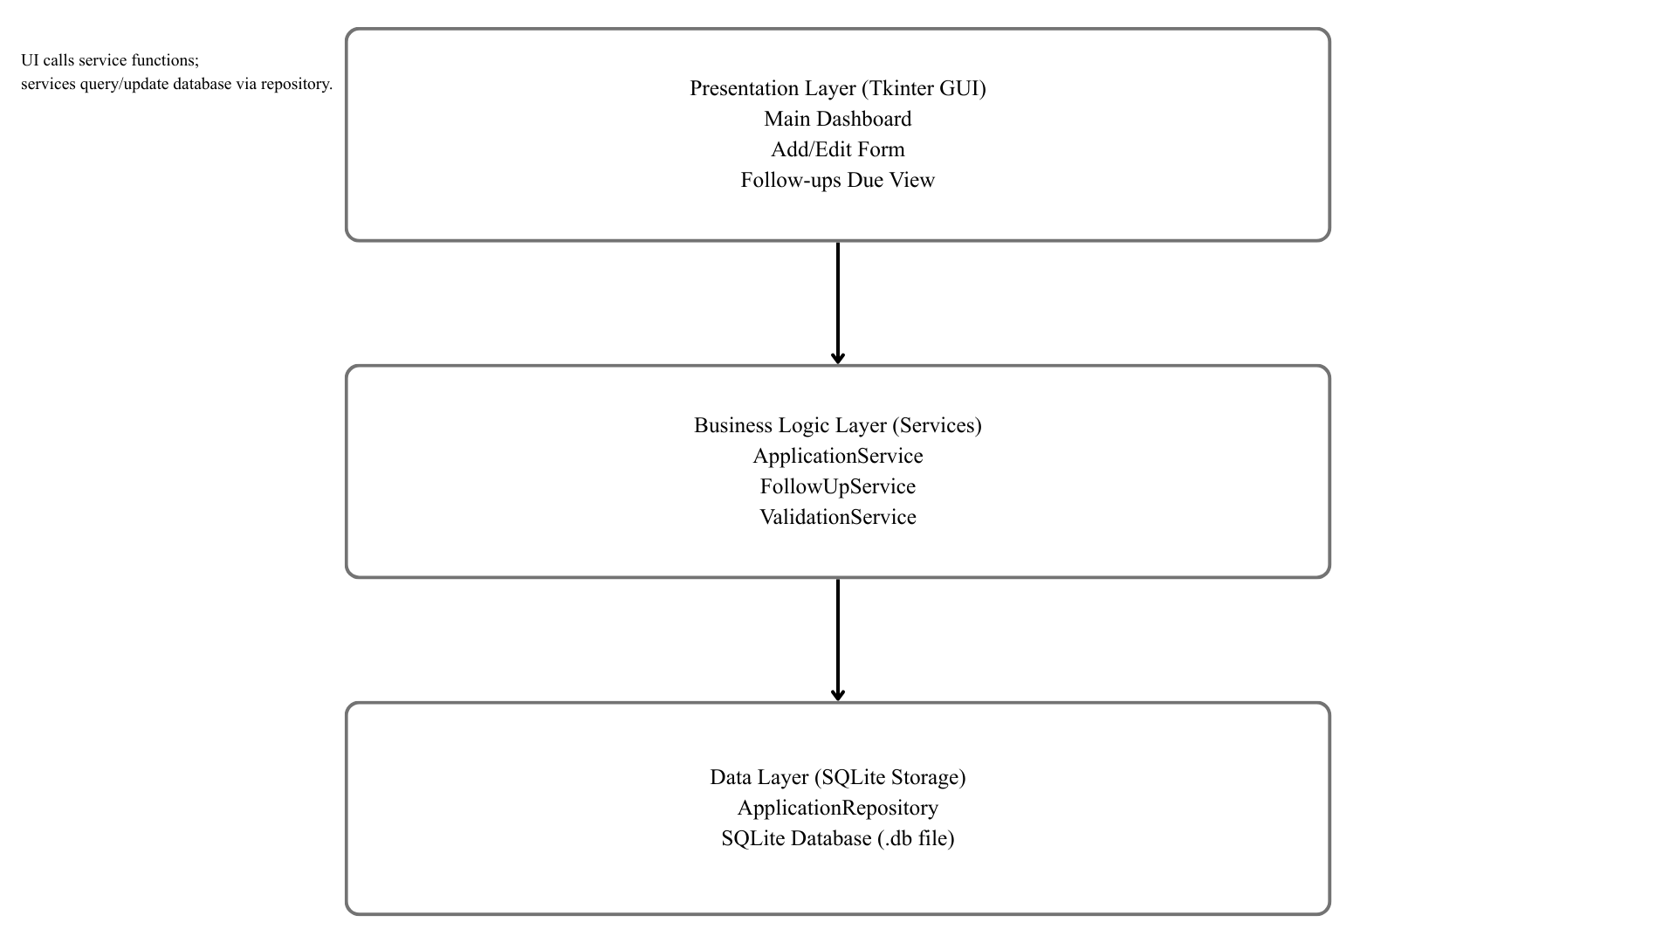
Figure 1
High-Level Architecture Diagram of the Internship Application Tracker.
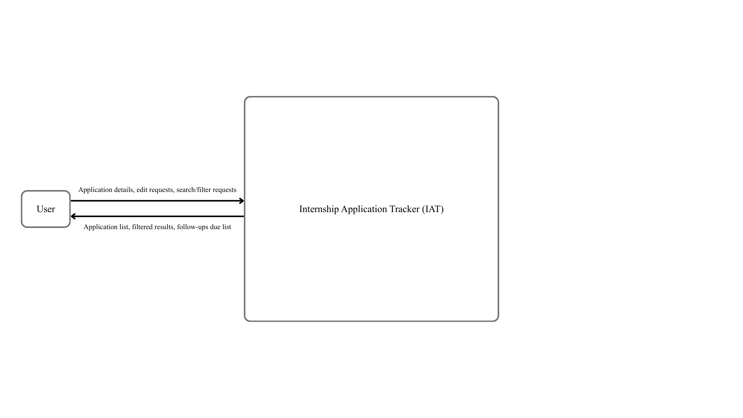
Figure 2
Level 0 Data Flow Diagram (Context Diagram).
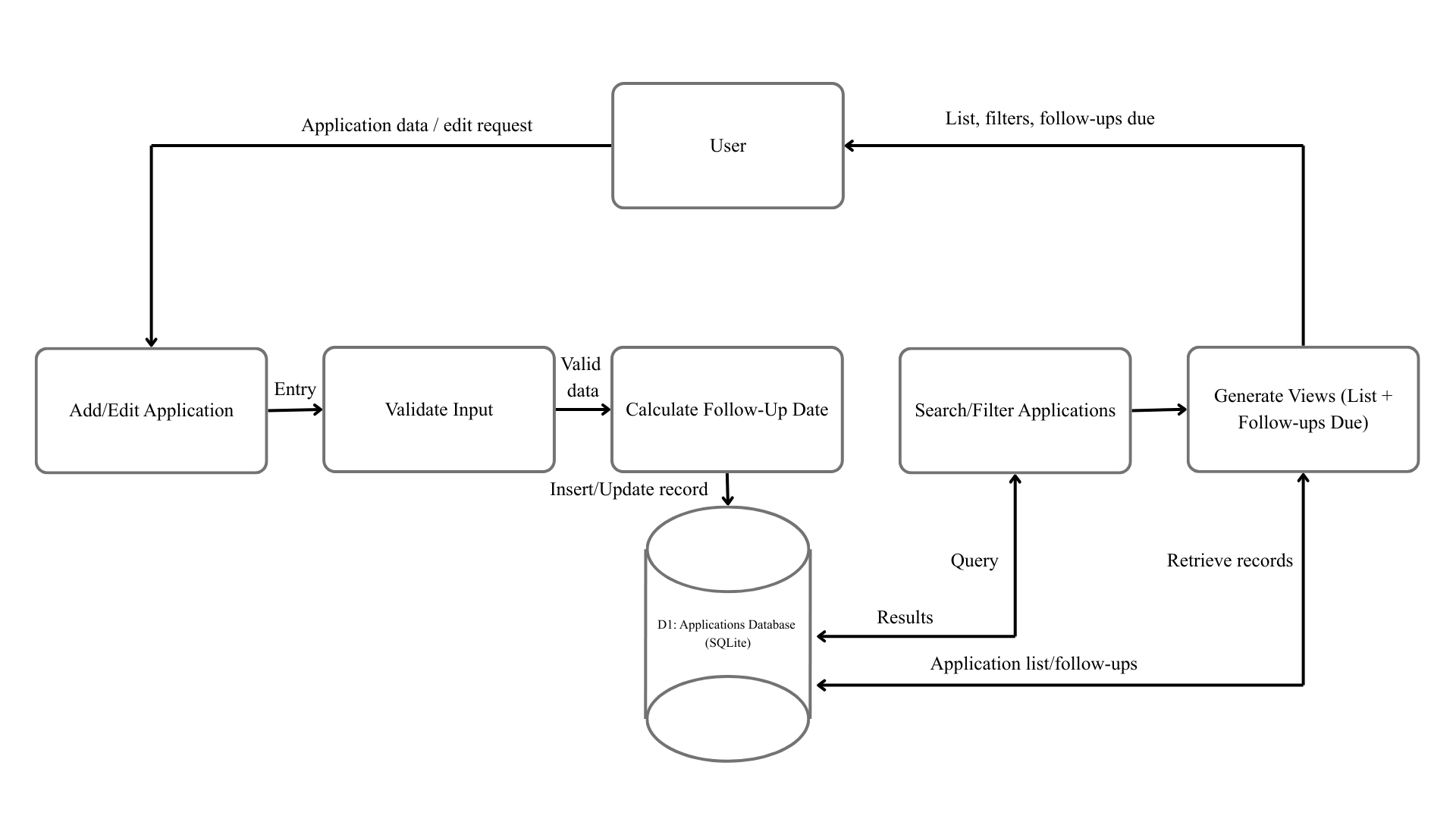
Figure 3
Level 1 Data Flow Diagram for Internship Application Tracker.
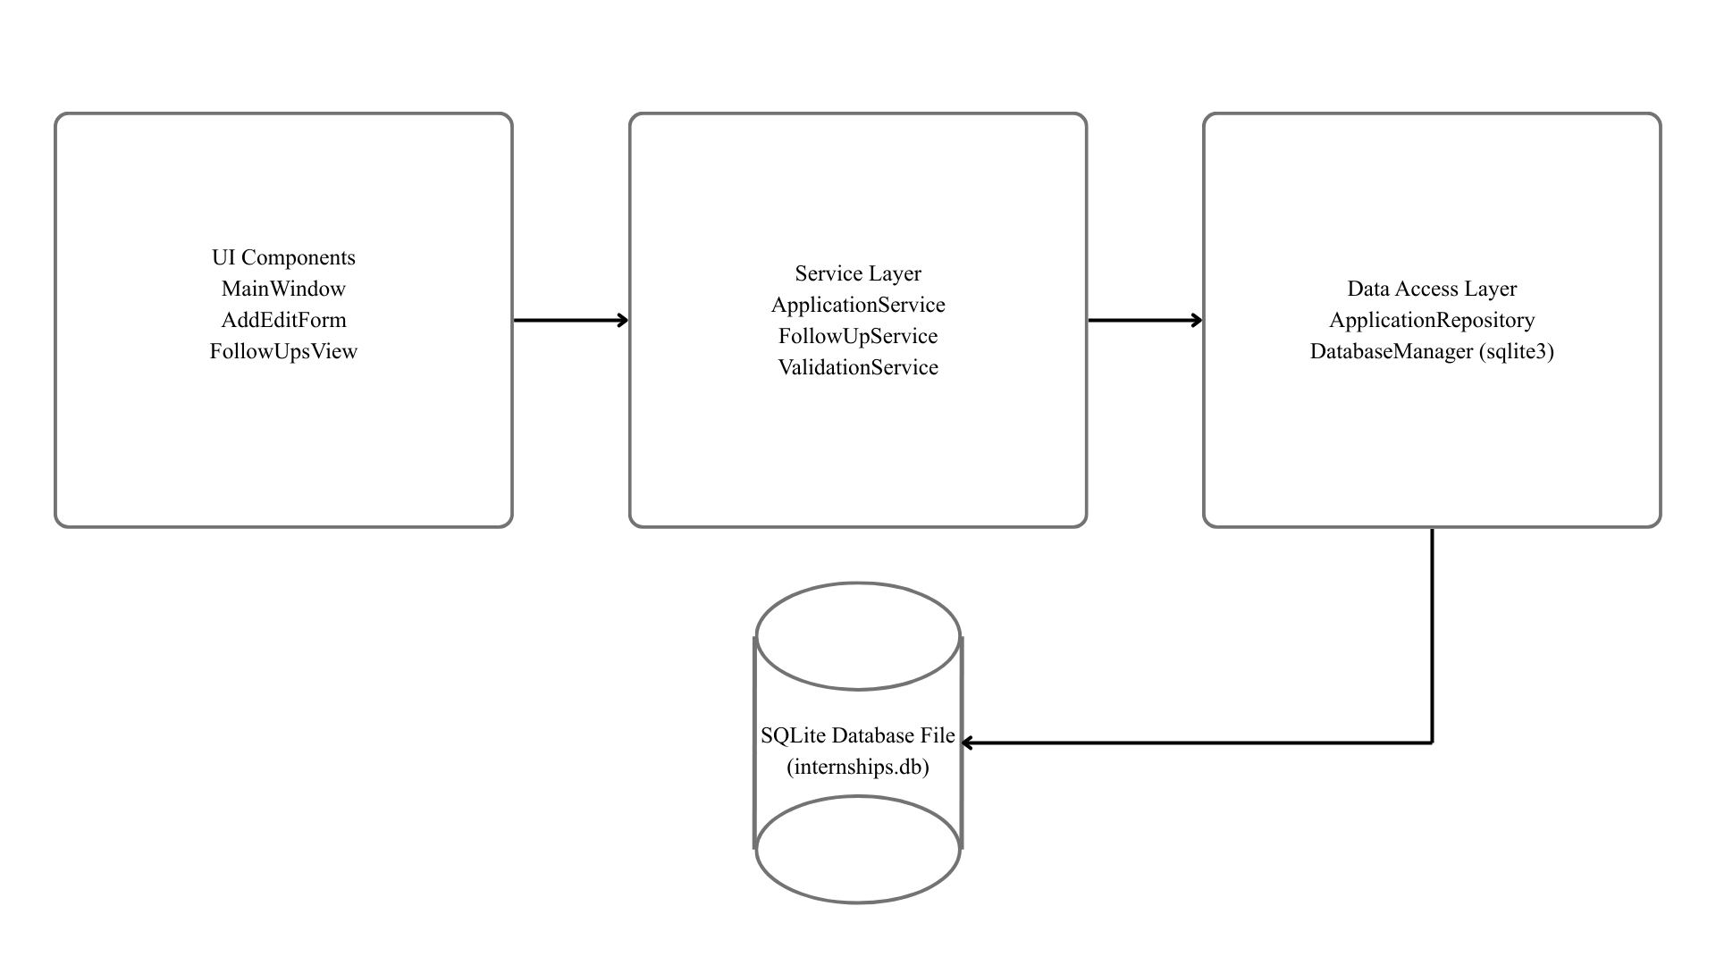
Figure 4
Component Diagram Showing System Modules.
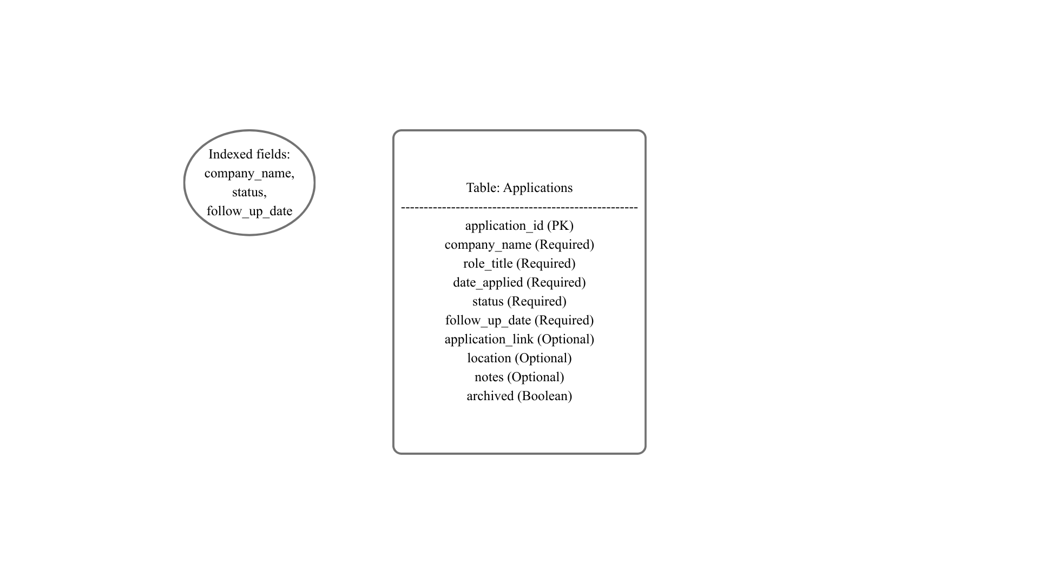
Figure 5
Database Schema for the Applications Table.

Detailed Planning
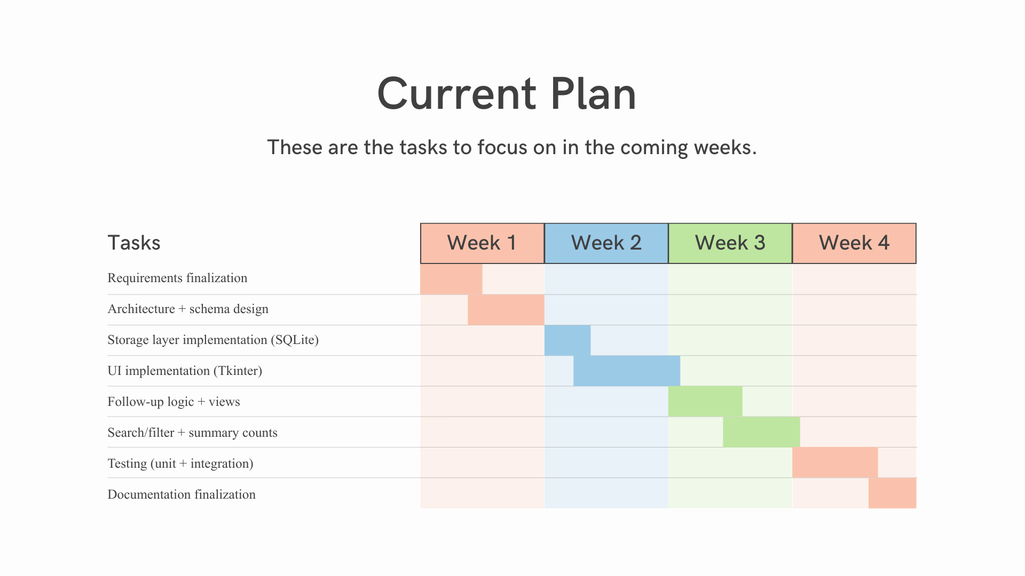
Figure 6
Gantt Chart for Internship Application Tracker Development Timeline.
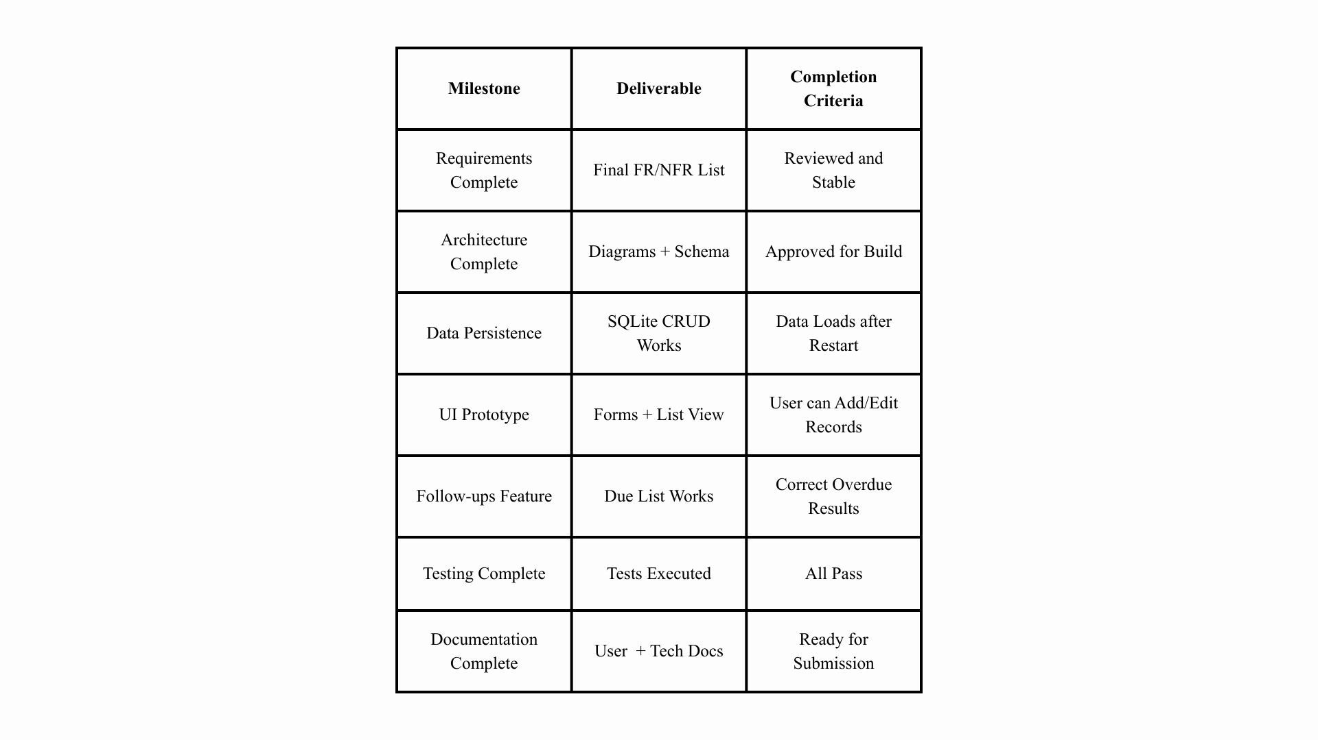
Figure 7
Project Milestones and Deliverables.
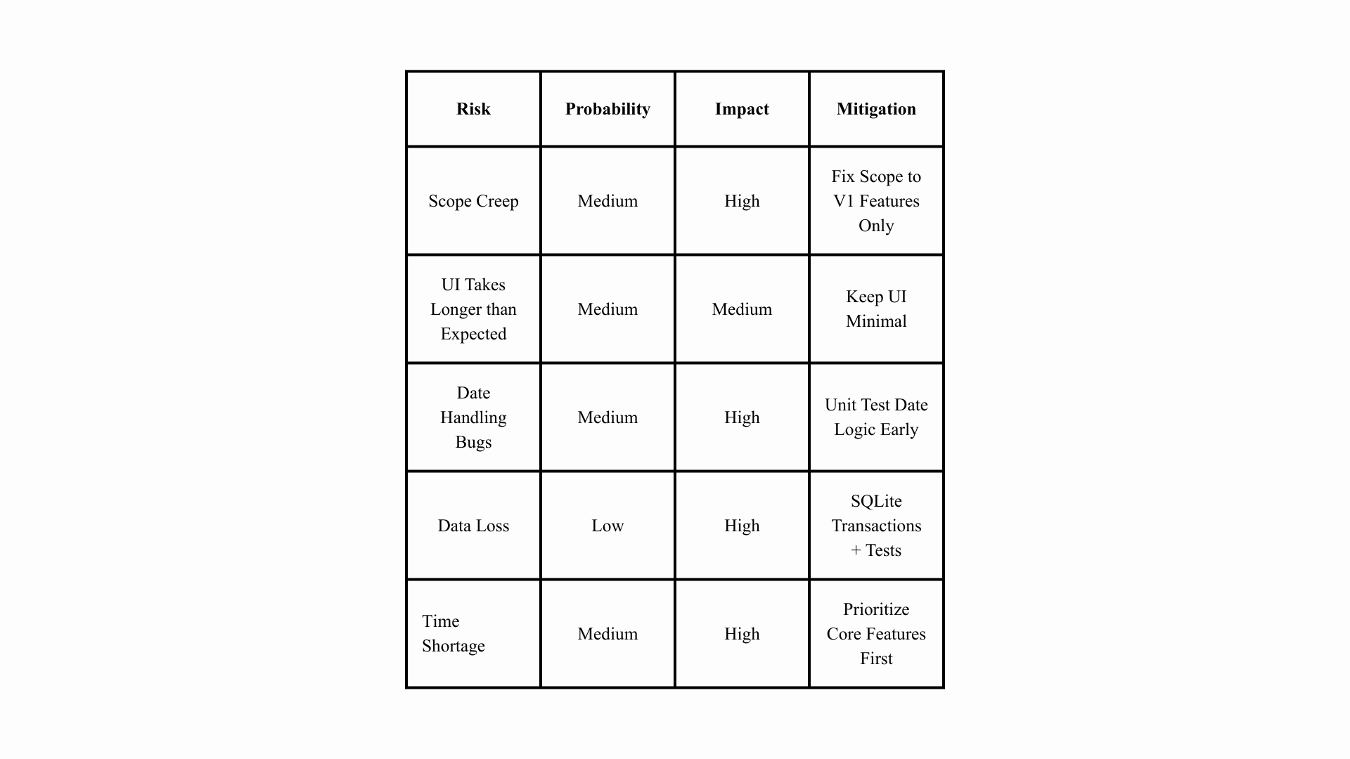
Figure 8
Risk Management Matrix.
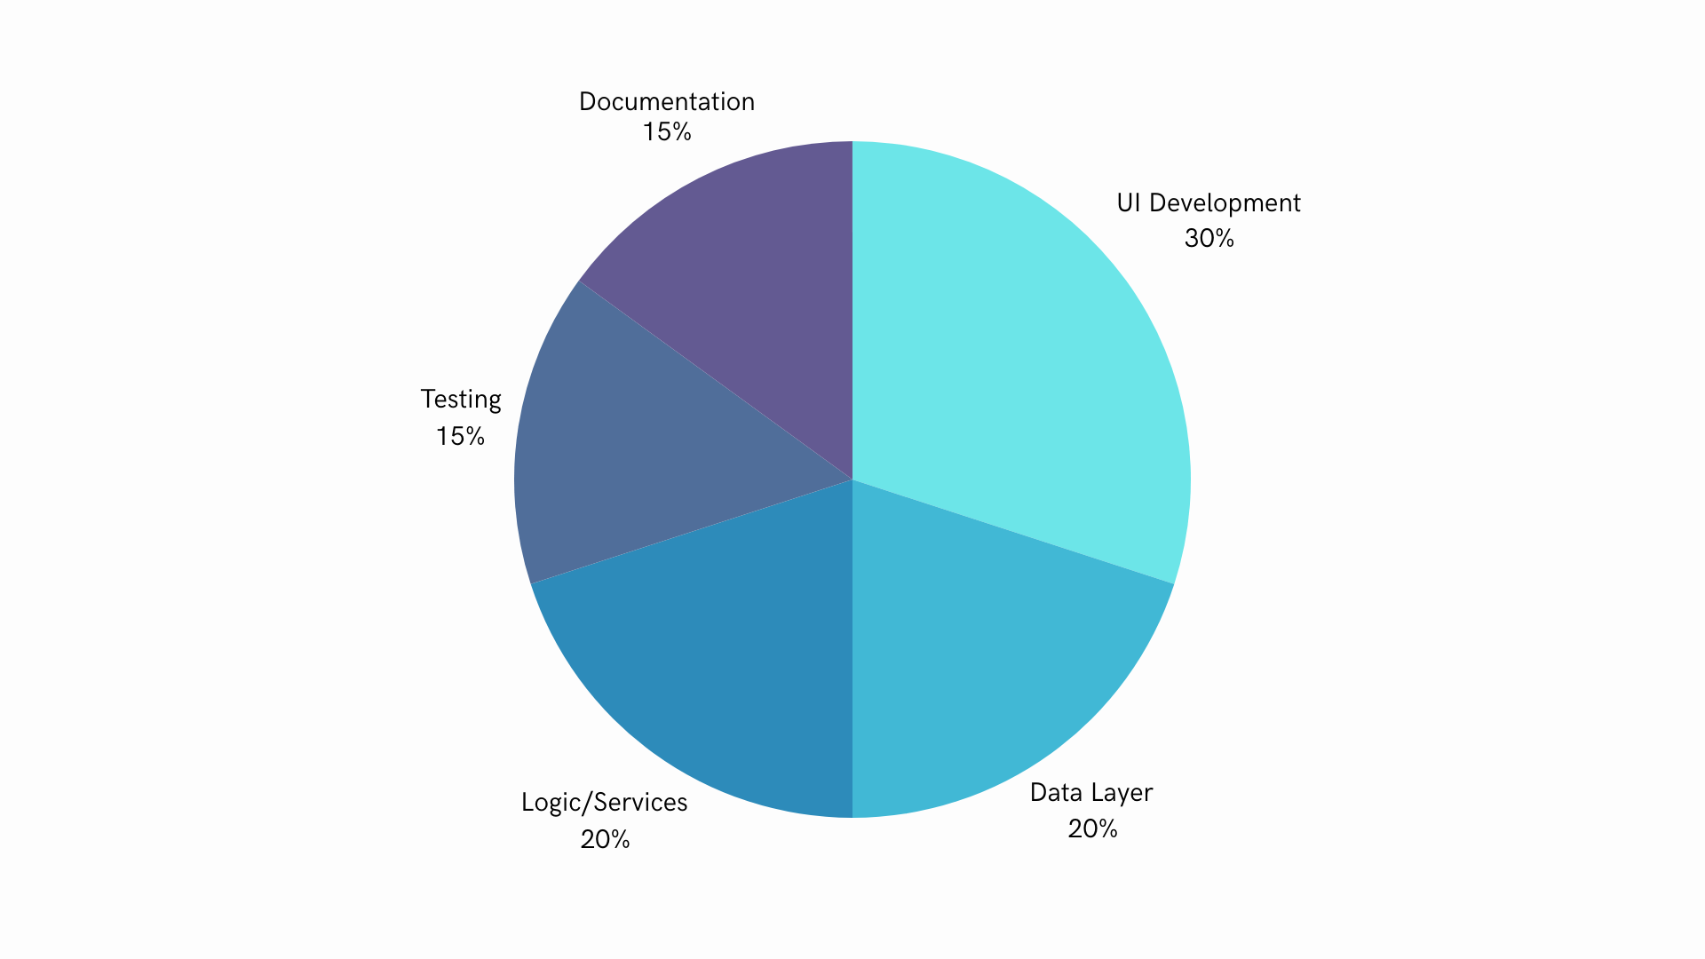
Figure 9
Resource Allocation Pie Chart.

Proposed Implementation
The IAT V1 will be implemented using Python due to its support of rapid development, it being the language learned in the course, its strong built-in and widely available libraries, and my desire to become better at using the language. A practical implementation approach is to use Python’s built-in SQLite library so that the application data remains structured, searchable, and reliable. For the interface, Tkinter is a suitable choice as it comes with Python and is sufficient for the forms, tables, and filters needed for this application.
The project will follow standard Python conventions, including PEP 8 formatting, meaningful names for variables and functions, and modular organization. The codebase will be separated into components such as storage, UI, and services for all functionalities. Finally, input validation will be performed prior to saving entries to prevent invalid states like missing fields or invalid dates.

Testing and Validation
Testing will include unit testing and integration testing to verify that the software meets all functional requirements. Unit tests will validate core logic, such as follow-up calculations, input validation, searching, and filtering. Integration testing will confirm that the UI actions correctly interact with the storage system. Additionally, basic usability testing will be performed to ensure that the average user can easily perform basic actions like adding, editing, and deleting entries to ensure that the flow of the application is intuitive.
# | Test Case Title | Steps and Expected Output
1 | Add application (Valid input) | Steps: Enter required fields (Company, Role, Date Applied, Status) and save.  Expected: Entry appears in list view and is stored persistently.
2 | Add application (Missing field) | Steps: Leave the Company blank and click save.  Expected: System blocks save and display an error message.
3 | Follow-up date calculation | Steps: Create an application entry with the date set to 2026-02-01.  Expected: Follow-up date set to 2026-02-11.
4 | Manual follow-up date override | Steps: Override the Follow-up date to a different date and save.  Expected: Follow-up date remains the user-selected value after reopen.
5 | Edit application | Steps: Edit an existing entry (change status to Interviewing).  Expected: Updated status is shown immediately and persists after a restart.
6 | Delete application | Steps: Delete an entry.  Expected: Entry is removed and does not reappear after a restart.
7 | Archive application | Steps: Mark an entry as Archived.  Expected: Entry no longer appears in the active list but can be viewed in the archived filter.
8 | Filter by status | Steps: Filter list by “Applied.”  Expected: Only entries with status “Applied” are shown.
9 | Search by company name | Steps: Search “Target” or “Software Intern.”  Expected: Matching entries are shown; non-matching entries are hidden.
10 | Follow-up due view (Overdue) | Steps: Create an entry with a follow-up date earlier than today.  Expected: Entry appears in Follow-ups Due and is marked overdue.
11 | Summary count accuracy | Steps: Create entries across multiple statuses.  Expected: Summary counts match the actual number of entries per status.
12 | Load performance | Steps: Populate the dataset with ~500 entries (test data).  Expected: App loads main list view within 2 seconds.

Table 2
Test Case Table

Documentation
The documentation for the Internship Application Tracker will include both a user manual and technical documentation. The user manual will explain how to create a new application entry, including which fields are required versus optional. It will also describe how to update the status of an application, use the search and filtering features, and view the “Follow-ups Due” section to interpret upcoming and overdue follow-up indicators. In addition, the user manual will provide instructions for editing, archiving, and deleting entries. Finally, a troubleshooting section will be included to help users resolve common problems, such as why an entry cannot be saved or how to correct an incorrect date.
The technical documentation will focus on how the system works internally and how it is structured. It will include an overview of the system’s purpose and scope, clearly defining which features are included in Version 1 (V1) and which features are excluded. It will also describe the main modules of the system, including the user interface, application logic/services, and local storage. In addition, the documentation will provide a data model description, including tables, key fields, and relationships used to store application information. The follow-up calculation rule will be defined in detail, along with validation rules for each input field to ensure data integrity. The technical documentation will also include a summary of the testing strategy, along with the list of test cases used to verify requirements. Finally, setup instructions will be provided, including the expected Python version, any dependencies, and how to run the program.
The appendix will contain supporting materials that reinforce the main sections of the paper. This will include the full list of functional and non-functional requirements, the test case table, and definitions of the application status categories used throughout the system.

References
No external sources were used in this assignment.

